**TSQL Homework 08b**

**Question 1**

The sales tax rate for a state just changed. How would you update the state tax table to reflect the changes? Assume that this table has an ID column, an RATE column, an a STATE column.

**Answer**

Update dbo.OrderDetails

Set stateTax = stateTax * 1.08

Where state = Maryland

**Question 2**

The Revenue Division has requested that you provide a report on what the actual sales taxes would have been for all order in the past year, assuming the retroactivity of the new sales tax rate. How would you calculate this?

**Answer**

Update od

Set stateTax += 8

From dbo.OrderDetails as OD

Inner join dbo.orders as o

On od.stateTax = O.stateTax

Where date > dateadd(year, -1, getadd);

**Question 3**

Explain how the proprietary assignment update command works.

**Answer**

An update statement changes the data of one or more records in a table. Either all the rows can be updated, or a subset may be chosen using a condition.

**Question 4**

What is one very important purpose of the MERGE SQL statement? What is ETL (not in book)?

**Answer**

The merge statement is used to make changes in one table based on values matched from another. It can be used to combine insert, update, and delete operations into one statement. ETL stands for Extract, Transform and Load, which is a process used to collect data from various sources, transform the data depending on business rules/needs and load the data into destination database.

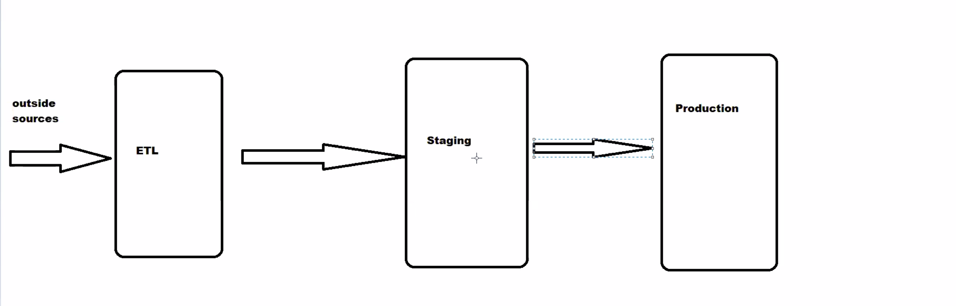

**Question 5**

What are the semantics of MERGE?

**Answer**

MERGE INTO dbo.Customers AS TGT

USING dbo.CustomersStage AS SRC

ON TGT.custid = SRC.custid

WHEN MATCHED THEN

UPDATE SET

TGT.companyname = SRC.companyname,

TGT.phone = SRC.phone,

TGT.address = SRC.address

WHEN NOT MATCHED THEN

INSERT (custid, companyname, phone, address)

VALUES (SRC.custid, SRC.companyname, SRC.phone, SRC.address);

**Question 6**

Write a typical INSERT OUTPUT statement.

**Answer**

INSERT INTO dbo.T1(datacol)

OUTPUT inserted.keycol, inserted.datacol

SELECT lastname

FROM HR.Employees

WHERE country = N'USA';

**Question 7**

Write a typical UPDATE OUTPUT statement.

**Answer**

UPDATE dbo.OrderDetails

SET discount += 0.05

OUTPUT

inserted.orderid,

inserted.productid,

deleted.discount AS olddiscount,

inserted.discount AS newdiscount

WHERE productid = 51;

**Question 8**

Write a typical DELETE OUTPUT statement.

**Answer**

DELETE FROM dbo.Orders

OUTPUT

deleted.orderid,

deleted.orderdate,

deleted.empid,

deleted.custid

WHERE orderdate < '20160101';

**Question 9**

Write a typical MERGE OUTPUT statement.

**Answer**

MERGE INTO dbo.Customers AS TGT

USING dbo.CustomersStage AS SRC

ON TGT.custid = SRC.custid

WHEN MATCHED THEN

UPDATE SET

TGT.companyname = SRC.companyname,

TGT.phone = SRC.phone,

TGT.address = SRC.address

WHEN NOT MATCHED THEN

INSERT (custid, companyname, phone, address)

VALUES (SRC.custid, SRC.companyname, SRC.phone, SRC.address)

OUTPUT $action AS theaction, inserted.custid,

deleted.companyname AS oldcompanyname,

inserted.companyname AS newcompanyname,

deleted.phone AS oldphone,

inserted.phone AS newphone,

deleted.address AS oldaddress,

inserted.address AS newaddress;

**Question 10**

What is nested DML?

**Answer**

You can use it to directly insert into the final target table only the subset of rows you need from the full set of modified rows.

DROP TABLE IF EXISTS dbo.ProductsAudit, dbo.Products;

CREATE TABLE dbo.Products

(

productid INT NOT NULL,

productname NVARCHAR(40) NOT NULL,

supplierid INT NOT NULL,

categoryid INT NOT NULL,

unitprice MONEY NOT NULL CONSTRAINT DFT_Products_unitprice DEFAULT(0), discontinued BIT NOT NULL CONSTRAINT DFT_Products_discontinued DEFAULT(0), CONSTRAINT PK_Products PRIMARY KEY(productid), CONSTRAINT CHK_Products_unitprice CHECK(unitprice >= 0) );

**Question 11**

(Not in the book) Write a query adding a new column to a table name PERSON. The new column name is DayOfBirth and the data type is string. Use ANSI SQL syntax.

**Answer**

Alter table Person

Add DayOfBirth str;

**Question 12**

(Not in the book) Write a query adding a DEFAULT constraint to the column DayOfBirh. The constraint is that the value matches one of SUN, MON, TUE, WED, THR, FRI, or SAT.

**Answer**

Add constraint D_Day default

Constraint CHK_DayOfBirth

CHECK (DayOfBirth like '[SUN], [MON], [TUE], [WED], [THU]. [FRI], [SAT]')

For DayOfBirth;

**Question 13**

(Not in the book) Write a query adding a foreign key to the column DayOfBirth. The referenced table is name WEEK and the referenced column is ValidDay.

**Answer**

Constraint FK_Week

Foreign key DayOfBirth

References Week(ValidDay)